**Experiment Number - 2**

**Student Name:** ANIKET KUMAR **UID:** 20BCS5306

**Branch:** CSE **Section/Group:** 20BCS_WM-703 / B

**Semester:** 5th **Date of Performance:** 25th Aug, 2022

**Subject Name:** PBLJ LAB **Subject Code:** 20CSP-321

**1. Aim/Overview of the practical:** The goal of this project is to design and implement a simple inventory control system for a small video rental store. Define least two classes: a class Video to model a video and a class VideoStore to model the actual store. Assume that an object of class Video has the following attributes:

1. A title;

2. a flag to say whether it is checked out or not;

3. An average user rating.

Add instance variables for each of these attributes to the Video class. In addition, you will need to add methods corresponding to the following:

1. being checked out;
2. being returned;
3. receiving a rating.

The VideoStore class will contain at least an instance variable that references an array of videos (say of length 10). The VideoStore will contain the following methods:

1. addVideo(String): add a new video (by title) to the inventory;

2. checkOut(String): check out a video (by title);

3. returnVideo(String): return a video to the store;

4. receiveRating(String, int) : take a user's rating for a video;

5. listInventory(): list the whole inventory of videos in the store.

Finally, create a VideoStoreLauncher class with a main() method which will test the functionality of your

other two classes. It should allow the following:

1. Add 3 videos: "The Matrix", "Godfather II", "Star Wars Episode IV: A New Hope".

2. Give several ratings to each video.

3. Rent each video out once and return it.

List the inventory after "Godfather II" has been rented out.

?

**2. Task to be done/ Which logistics used:**

IntelliJ IDEA (IDE), JDK.

**3. Program Code:**

import java.util.Scanner;  
  
class Video {  
 String title;  
 boolean Flag = false;  
 int avg = 0;  
}  
class VideoStore {  
 private static final Scanner *input* = new Scanner(System.*in*);  
 String chek2;  
 Video beat[] = new Video[10];  
 int num_video;  
 void addVideo() {  
 System.*out*.println("Enter " + num_video + " Video Title:- ");  
 for (int i = 0; i < num_video; i++) {  
 beat[i] = new Video();  
 beat[i].title = *input*.nextLine();  
 }  
 System.*out*.println("Enter " + num_video + " Video rating between 1 to 5:- ");  
 for(int i = 0; i < num_video; i++) {  
 beat[i].avg= *input*.nextInt();  
 }  
 }  
 int chekOut(int k) {  
 String chek1;  
 System.*out*.println("chekout " + (k + 1));  
 chek1 = *input*.next();  
 for (int i = 0; i < num_video; i++) {  
 if (beat[i].title.equals(chek1) && (beat[i].Flag == false)) {  
 beat[i].Flag = true;  
 return -1;  
 } else if (beat[i].title.equals(chek1) && (beat[i].Flag == true)) {  
 System.*out*.println("Failed to chekout: ");  
 return -1;  
 }  
 }  
 return 1;  
 }  
 int returnvideo(int k) {  
 System.*out*.println("Returning Video name: " + (k + 1));  
 chek2 = *input*.next();  
 for (int i = 0; i < num_video; i++) {  
 if (beat[i].title.equals(chek2) && beat[i].Flag == true) {  
 System.*out*.println("Video " + chek2 + " is returned");  
 this.reciveRating();  
 beat[i].Flag = false;  
 return -1;  
 } else if (beat[i].title.equals(chek2) && beat[i].Flag == false) {  
 System.*out*.println("U cannot return this!");  
 return -1;  
 }  
 }  
 return 1;  
 }  
 void reciveRating() {  
 System.*out*.println("Enter the rating between 1 to 5: ");  
 for (int i = 0; i < num_video; i++) {  
 if (beat[i].title.equals(chek2) && beat[i].Flag == true) {  
 beat[i].avg = *input*.nextInt();  
 }  
 }  
 }  
 void listInventory() {  
 System.*out*.println("List of all Videos: ");  
 int total = 0;  
 for (int i = 0; i < num_video; i++) {  
 if (beat[i].Flag == false) {  
 System.*out*.println(beat[i].title + " Not chekout");  
 } else {  
 System.*out*.println(beat[i].title + " Chekout!");  
 total += 1;  
 }  
 if (beat[i].avg != 0) {  
 System.*out*.println("Rating:- " + beat[i].avg + " Star ");  
 }  
 }  
 System.*out*.println("Total number of chekout video: " + total);  
 }  
}  
public class VideoStoreLauncher {  
 public static void main(String[] args) {  
 VideoStore box = new VideoStore();  
 int chekout;  
 int ret;  
 Scanner in = new Scanner(System.*in*);  
 System.*out*.println("Number of video: ");  
 box.num_video = in.nextInt();  
 box.addVideo();  
 System.*out*.println("How Many video u wants to chekout: 0 if u don't");  
 chekout = in.nextInt();  
 int chek = 1;  
 int chek1 = 1;  
 if (chekout != 0) {  
 for (int i = 0; i < chekout; i++) {  
 chek = box.chekOut(i);  
 if (chek == 1) {  
 System.*out*.println("Video Not Present");  
 }  
 }  
 }  
 System.*out*.println("How Many video u wants to Return: 0 if u don't");  
 ret = in.nextInt();  
 if (ret != 0) {  
 for (int i = 0; i < ret; i++) {  
 chek1 = box.returnvideo(i);  
 if (chek1 == 1) {  
 System.*out*.println("Wrong input!");  
 }  
 }  
 }  
 box.listInventory();  
 }  
}

1. **Output :**

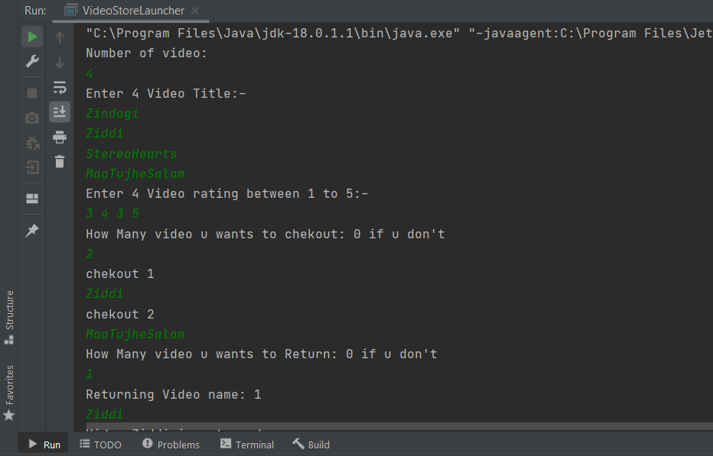

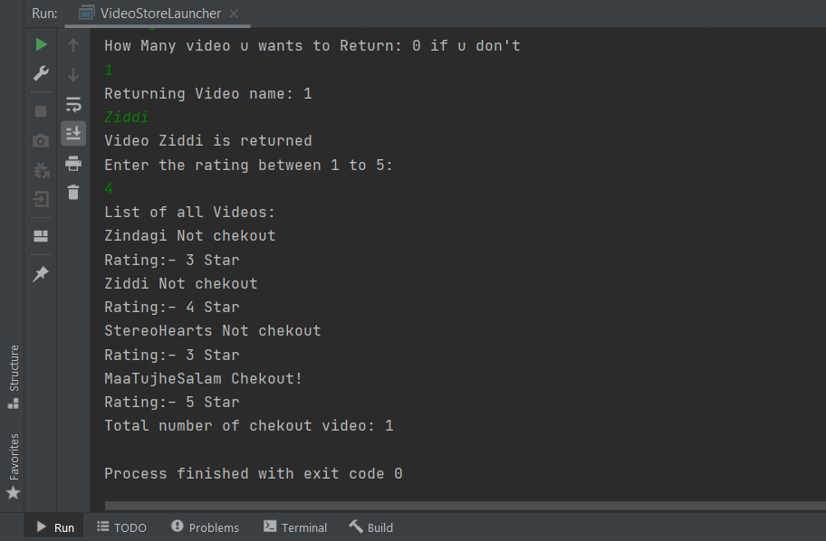

**Learning outcomes (What I have learnt):**

1. I have learnt how to write program in JAVA.
2. I have learnt how to create classes and its objects in JAVA.
3. I have learnt how to take input from user using Scanner class.
4. I have learnt how to create Array in JAVA and traverse each elements using loop.
5. I have learn how to create an application (i.e inventory control system for a small video rental store) using JAVA.

**Evaluation Grid (To be created as per the SOP and Assessment guidelines by the faculty):**

|  |  |  |  |
| --- | --- | --- | --- |
| Sr. No. | Parameters | Marks Obtained | Maximum Marks |
| 1. |  |  |  |
| 2. |  |  |  |
| 3. |  |  |  |
|  |  |  |  |